Aidan Mazur

Biology 152

Lab 701

05/03/2013

Spectral Signatures Vary Among Leaf and Canopy Level Measurements and Among

Canopy Structure

ABSTRACT
Spectral reflectance measurements of leaf and canopy levels provide important information about how plants use light, and convey information about pigments, chemical constituents, and water content. All of these factors influence photosynthetic rates. However, reflectance measurements made at the leaf level and canopy level are potentially not comparable due to differences caused by interior canopy shading and leaf angle, and the larger leaf surface area available to reflect light in a canopy compared with an individual leaf. Therefore, inferences about the physiological processes of the whole plant are potentially confounded. Canopy level reflectance measurements are incredibly important because they provide information about large areas of vegetation without the need to measure each individual plant. Understanding more about the canopy scale reflectance measurements can provide us with information regarding ecosystem processes such as carbon sequestration and nitrogen cycling. Leaf level reflectance measurements were collected using a field spectrometer and a synthetic canopy was created using various arrangements of red amaranth (Amaranthus blitum). Our results showed that, overall, canopy reflectance was 9% higher than leaf level reflectance at 1100nm in the near infrared region. Photochemical reflectance index (PRI) was not affected by scale of measurement, however, normalized difference vegetation index (NDVI) and normalized difference water index (NDWI) were both higher when spectra were collected from a simulated canopy than individual leaves. Our findings demonstrate that reflectance is higher when measurements are collected using remote sensing techniques, compared to contact techniques, and that vegetation indices change proportionally.

INTRODUCTION
Forests play a vital role in many biological processes on our planet, which provide necessary services for life on earth (Bonan 2008; Ollinger et. al. 2002). The ability of forests to assimilate carbon from atmospheric carbon dioxide is a major driver of biogeochemical cycles, which in turn provide necessary food and habitat for animals, including humans (Wright et. al. 2004, Melillo et. al. 2003; Ollinger and Smith 2005). This carbon uptake also has substantial environmental implications (Bonan 2008). Forests store ~45% of terrestrial carbon and are responsible for ~33% of terrestrial carbon sink, accounting for the absorption of large amounts of carbon emissions from the burning of fossil fuels (Bonan 2008). Nitrogen has also been greatly studied in respect to its role as a limiting element in plant growth and as an essential building block of amino and nucleic acids (Ollinger et. al. 2002; Wright et. al. 2004). Since nitrogen plays such an important role in ecosystem functioning, various analyses have been conducted that use remote sensing to detect nitrogen concentrations in differing environments.
Measuring forest processes such as carbon and nitrogen cycling is a challenge due to the size of the area being studied and varying rates of carbon and nitrogen intake. Analysis of these processes can provide vital information about forest growth and the health of the ecosystem as a whole. Remote sensing is an accurate and easy way to study various aspects of forests (and many other ecosystems). Remote sensing involves gathering information about something without having to make contact with the object being investigated (Kirman 1997). When gathering information about forests, measurements are the result of interfaces between electromagnetic radiations emitted by the sun, which reflect off surfaces and are then collected by a sensor which splits the radiation into bands to create what is called a hyperspectral image (Wulder 1998; Boyd and Dansen 2005). Hyperspectral remote sensing data of forests can be collected from aircrafts or even from space via satellites. (Ollinger and Smith 2005). As more studies integrate remote sensing, and as technology improves, it has been found that a plethora of information can be gathered from these hyperspectral readings. On a broad scale, remote sensing can give us information about the forest as a whole, including land use, species composition, and vegetation type (Ollinger and Smith 2005; Kokaly et. al. 2009; Boyd and Dansen 2005). Various experiments have also found that high spectral resolution remote sensing can provide information about the chemical and biochemical properties of leaves and canopies, including leaf composition and the levels of elements present, such as carbon and nitrogen (Asner and Martin 2008; Kokaly et. al. 2009, Jacquemound et. al. 2009; Ollinger and Smith 2005; Ollinger 2010). Information about physical leaf properties (chlorophyll levels and types, cellulose content, lignin content) and canopy composition and density can also be gathered using remote sensing (Asner and Martin 2008; Kokaly et. al. 2009; Boyd and Dansen 2005).
Using remote sensing, properties of leaves and canopies, such as water content and moisture stress, can be gathered (Asner and Martin 2008). This information can be found by analyzing the reflectance measurements, which can show how plants are reacting to environmental stressors such as drought. Gathering measurements of these forest processes under different conditions allows us to extrapolate how climate change and human interference are affecting these ecosystems, and can model future forest events given present climate and use trends (Ollinger 2010).
In order to find information about plant properties, combinations of two or more wavelengths, or vegetation indices, are used (Boyd and Denson 2005). Indices are vastly important because they give scientists a relatively accurate and easy way to gather information about a wide range of plant properties using basic hyperspectral collections. For this experiment, we used three different indices: photochemical reflectance index (PRI), normalized difference vegetation index (NDVI), and normalized difference water index (NDWI). PRI is a measurement of photosynthetic light use efficiency in plants (Sims and Gamon 2002; Ollinger 2010; Gamon et al 1992). NDVI is a vegetation index that has been linked with many properties of plants, including vegetation cover, biomass, chlorophyll content, and even primary production (Ollinger 2010; Gamon et al 1992). NDWI is an index used to measure plant water content (Gao 1996). By calculating these indices at both the leaf level and canopy level, we can see if changes occur between these scales, and if so, are patterns apparent.
In this experiment, we gathered hyperspectral reflectance measurements from individual leave (leaf-level) using a contact probe and compared these data to hyperspectral measurements on a synthetic canopy (canopy-level). We also included a nitrogen fertilization treatment to see if changes in reflectance between fertilized and non-fertilized plants seen at the leaf level could also be seen at the canopy level. We hypothesize that 1) variation in reflectance will be seen when comparing leaf level and canopy level data, and 2) that the indices calculated will change when reflectance is collected at either the leaf or canopy level.

METHODS
For this experiment, 24 amaranth plants were grown in a greenhouse under normal lighting and atmospheric conditions. Plants were given six weeks to germinate and grow before data collection began. On week six, 12 of the plants were given a nitrogen fertilization treatment.

Leaf Level Reflectance Data
For individual leaf level reflectance data, an ASD FieldSpec 3 spectroradiometer was used. A plant probe and leaf clip assembly was attached to the spectroradiometer (Figure 1). Baseline individual contact leaf level data was collected on week six, and contact leaf level data was then collected from fertilized plants on week seven. Before data was collected, the spectroradiometer was allowed 15 minutes to warm up. Next, the system was optimized, and then, using a Spectralon white reference puck (99% reflectance), the spectroradiometer was white referenced calibrated to establish an accurate baseline (Figure 1). This procedure adjusts the reflectance collections to account for background noise. Three leaf level measurements from two leaves were collected from each plant, for a total of six measurements per plant.

Collecting Canopy Level Reflectance Data
Canopy-level collections procedures varied greatly from that of the leaf level collection (Fig. 2). Plants were transported from the greenhouse to an enclosed lab room. The fiber optic was placed in a pistol grip with the bare optic emerging from the end collecting reflectance from a 25-degree field of view. The pistol grip was resting on a clamp such that the fiber optic cable was oriented straight down. A light source was then placed to shine on the same area as the fiber optic scope, held up by a tripod, and the light was oriented to shine on the same area from which the fiber optic was collecting reflectance data. The light was set to its most diffused level to prevent light saturation. Cardboard that was spray painted flat black was placed around the experimental area so that reflectance data was not collected from the side of the cardboard box that held the pistol grip, or the tabletop that the plants would be placed on. Four fertilized plants were placed below the fiber optic lens, so that the top of the plants (“canopy”) was approximately 12.5cm away from the bare optic cable. Instrument warm-up and optimization were the same as leaf-level collections. The spectralon white reference panel was held by hand below the fiber optic lens so that the panel was resting on top of the canopy of the plants so that calibration was made at the same level from which the data would be collected. After the system was optimized and white referenced, four reflectance measurements were recorded from this arrangement of plants. The arrangement was then rotated 90 degrees clockwise to create a different arrangement. System was again optimized and white reference calibrated, and four reflectance measurements were taken. This process was repeated until arrangement had been rotated 360 degrees (four different arrangements were recorded, four reflectance measurements taken for each arrangement). The four fertilized plants were then replaced with four non-fertilized plants and the process was repeated. We excluded data that were outliers.
Three non-fertilized plants were then placed in the collection zone and four reflection measurements were taken. Two plants were then removed, and reflection measurements were again collected. This sequential data was collected to see if canopy density also played any role in the data collected.

Data Processing
Reflectance data were processed to adjust for spectra abnormalities averaged to increase data accuracy. Vegetation indices were calculated using equations shown in Table 1.

RESULTS
In the visible light spectrum, there was no substantial difference between canopy level and leaf level reflectance, regardless of fertilization (Fig. 3). In the Near Infrared (1100nm), fertilized plants had a canopy level reflectance that was 15% higher compared to the leaf level measurements (Fig 3). Non-fertilized plants had a canopy level reflectance that was 3% higher than leaf level reflectance in the near infrared (1100nm) (Fig. 3). When all canopy level data (regardless of fertilization) was compared to all leaf level data, it was found that in the visible light there was not a significant difference between canopy and leaf level reflectance (Fig. 3). However, in the near infrared (1100nm) canopy level reflectance was 9% higher than leaf level reflectance (Fig. 3).
The “denser” canopy (canopy consisting of three plants) had a 12% higher reflectance than the canopy consisting of just one plant in the near infrared region (1100nm), while no substantial difference was observed in the visible wavelength range (Fig. 3)
Fertilization increased PRI and decreased NDVI and NDWI (Table 2, Fig. 4). While PRI values collected from individual leaves or a simulated canopy did not differ, NDVI and NDWI values were both higher when spectra were collected from a simulated canopy than individual leaves (Table 2, Fig. 4). None of the effects of fertilization on the spectral indexes, we determined, were affected by whether the collections were made from individual leaves or a simulated canopy (no significant interaction effects). This result means that while the information changed when collected from either individual leaves or a simulated canopy, the effects of fertilization scaled proportionally.

DISCUSSION
The results of this experiment supported our hypothesis that changes can be seen between reflectance measurements of individual contact leaf level and canopy level measurements. Our findings suggest that reflectance is higher in canopy level measurements. The higher reflectance at the canopy level demonstrates that the spectral information collected changes when moving from contact to non-contact measurements. As discussed in Ollinger (2010), this could be due to the physical make up of the canopy and how the leaves are arranged and angled. When reflectance measurements are gathered using a contact probe, reflection is contained to a specific area on the leaf. However, measurements collected using remote sensing are also affected by surrounding leaves, shading, and other factors (Ollinger 2010). Additionally, when individual leaf reflectance is measured using a contact probe, there is only one opportunity for the light to get reflected because only one leaf is sampled and the angle of reflectance is perpendicular. However, when canopy reflectance is measured, light that passes through one leaf can still be reflected by another leaf or by another part of the plant. This response is supported in the sequential data (Fig. 3) where reflectance of a canopy containing three plants had higher reflectance than a canopy containing just one plant. We can thus conclude that canopy density will increase reflectance due to an increase in potential reflectance surface area. Because of this, information about leaf chemistry may be lost or gained when expanding from contact leaf level measurements to remote sensing canopy level measurements. As discussed in Asner and Martin (2008), continuing to find information linking plant chemical properties and spectral properties will help uncover more specific information from measurements that are gathered on larger scales using remote sensing. Important knowledge about the canopy itself can be gathered using remote sensing data such as canopy structure and physiology, which in turn can reveal valuable information about the cycling of carbon and nitrogen in forests, two elements crucial to life.
It was found through this experiment that the PRI measurement is not affected when moving from the individual contact leaf level to the canopy level. PRI is a measurement of light use efficiency, telling us information about the rate of carbon assimilation. Knowledge regarding carbon cycling and assimilation is relevant because the process drives many biological processes of forests. The knowledge that this index measurement remains consistent when moving from the leaf level to the canopy level means that information about carbon absorption and photosynthetic light use can be gathered at the leaf level, and can then be extrapolated to the larger scale of the forest.
NDVI and NDWI measurements did change when going from the leaf level to the canopy level. At the same time, NDVI and NDWI measurements were both lowered by fertilization. By taking this relationship into account, it was observed that this decrease in NDVI and NDWI due to fertilization at the leaf level was also seen in the canopy level. This shows that although the value of the indices themselves changes across special scales, the information that these indices provide can still be used because the way they change is proportional.
Information regarding canopy structure and physiology is important because it reveals details about forest carbon and nitrogen cycling. Carbon provides food and shelter for organisms on earth and nitrogen is a building block for amino and nucleic acids, making these elements crucial for life. However, as our climate changes, the way forests process elements such as carbon and nitrogen has already, and will continue to change. Being able to quantify how forest ecosystem processes are changing with changing climatic conditions will help us predict how organisms inside and outside of the ecosystem will be affected, and how the land itself will look in the future. Also, being able to see how forests deal with different conditions can show us possible ways to manipulate our landscape in order to combat any negative effects that climate change may have on these ecosystems, and ensure the survival of forests around the world.

Works Cited
Asner, G. P., and Martin, R. E. 2008. Spectral and chemical analysis of tropical forests: Scaling from leaf to canopy levels. Remote Sensing Environment. 112: 3958- 3970.
Bonan G. B. 2008. Forests and climate change: Forcings, feedbacks, and the climate
benefits of forests. Science. 320: 1444-1449.
Boyd, D. S., and Danson, F. M. 2005. Satellite Remote Sensing of Forest Resources: Three Decades of Research Development. Progress in Physical Geography. 29: 1-26.
Gamon, J. A., Penuelas, J., and Field, C. B. 1992. A Narrow-Waveband Spectral Index That Tracks Diurnal Changes in Photosynthetic Efficiency. Remote Sensing Environment 41: 35-44.
Gao, B. 1996. NDWI A Normalized Difference Water Index for Remote Sensing of Vegetation Liquid Water From Space. Remote Sensing Environment 58:257-266.
Jacquemoud S, Verhoef W, Baret F, Bacour C, Zarco-Tejada P, Asner G, François C, Ustin S. 2009. PROSPECT+SAIL models: A review of use for vegetation characterization. Remote Sensing of Environment. 113: 56-66.
Kirman, J. M. 1997. A Teachers Introduction To Remote Sensing. Journal of Geography. 96: 171-176.
Kokaly, R. F., Asner, G. P., Ollinger, S. V., Martin, M. E., Wessman, C. A. 2009. Characterizing canopy biochemistry from imaging spectroscopy and its application to ecosystem studies. Remote Sensing of Environment. 113: S78-S91.
Melillo, J. M., McGuire, A. D., Kicklighter, D. W., Moore III, B., Vorosmarty, C. J., Schloss, A. L. 1993. Global Climate change and Terrestrial Net Primary production. Nature. 363: 234-240.
Ollinger S. V. 2010. Sources of variability in canopy reflectance and the convergent
properties of plants. New Phytologist. 189: 375-394.
Ollinger S. V., and Smith M. L. 2005. Net Primary Production and Canopy Nitrogen in a
Temperate Forest Landscape: An Analysis Using Imaging Spectroscopy,
Modeling and Field Data. Ecosystems. 8: 760-778.
Ollinger S. V., Smith M. L., Martin M. E., Hallett R. A., Goodale C. L., and Aber J. D.
2002. Regional Variation in Foliar Chemistry and N Cycling Among Forests of
Diverse History and Composition. Ecology. 83: 339-355.
Tucker, C. J., Pinzon, J. E., Brown, M. E., Slayback, D. A., Pak, E. W., Mahoney, R., Vermote, E. F., and Saleous, N. E. 2005. An extended AVHRR 8-km NDVI dataset compatible with MODIS and SPOT vegetation NDVI data. International Journal of Remote Sensing 26: 4485-4498.
Wright, I. J., Reich, P. B., Westoby, M., Ackerly, D. D., Baruch, Z., Bongers, F., Cavender-Bares, J., Chapin, T., Cornelissen J. H. C., Diemer, M., Flexas, J., Garnier, E., Groom, P. K., Gulias, J., Hikosaka, K., Lamont, B. B., Lee, T., Lee, W., Lusk, C., Midgley, J. J., Navas, M., Niinemets, U., Oleksyn, J., Osada, N., Poorter, H., Poot, P., Prior, L., Pyankov, V. I., Roumet, C., Thomas, S. C., Tjoelker, M. G., Veneklaas, E. J., Villar, R. 2004. The Worldwide Leaf Economics Spectrum. Nature. 428: 821-827.
Wulder, M. 1998. Optical remote-sensing techniques for the assessment of forest inventory and biophysical parameters. Progress in Physical Geography. 22: 449- 476.

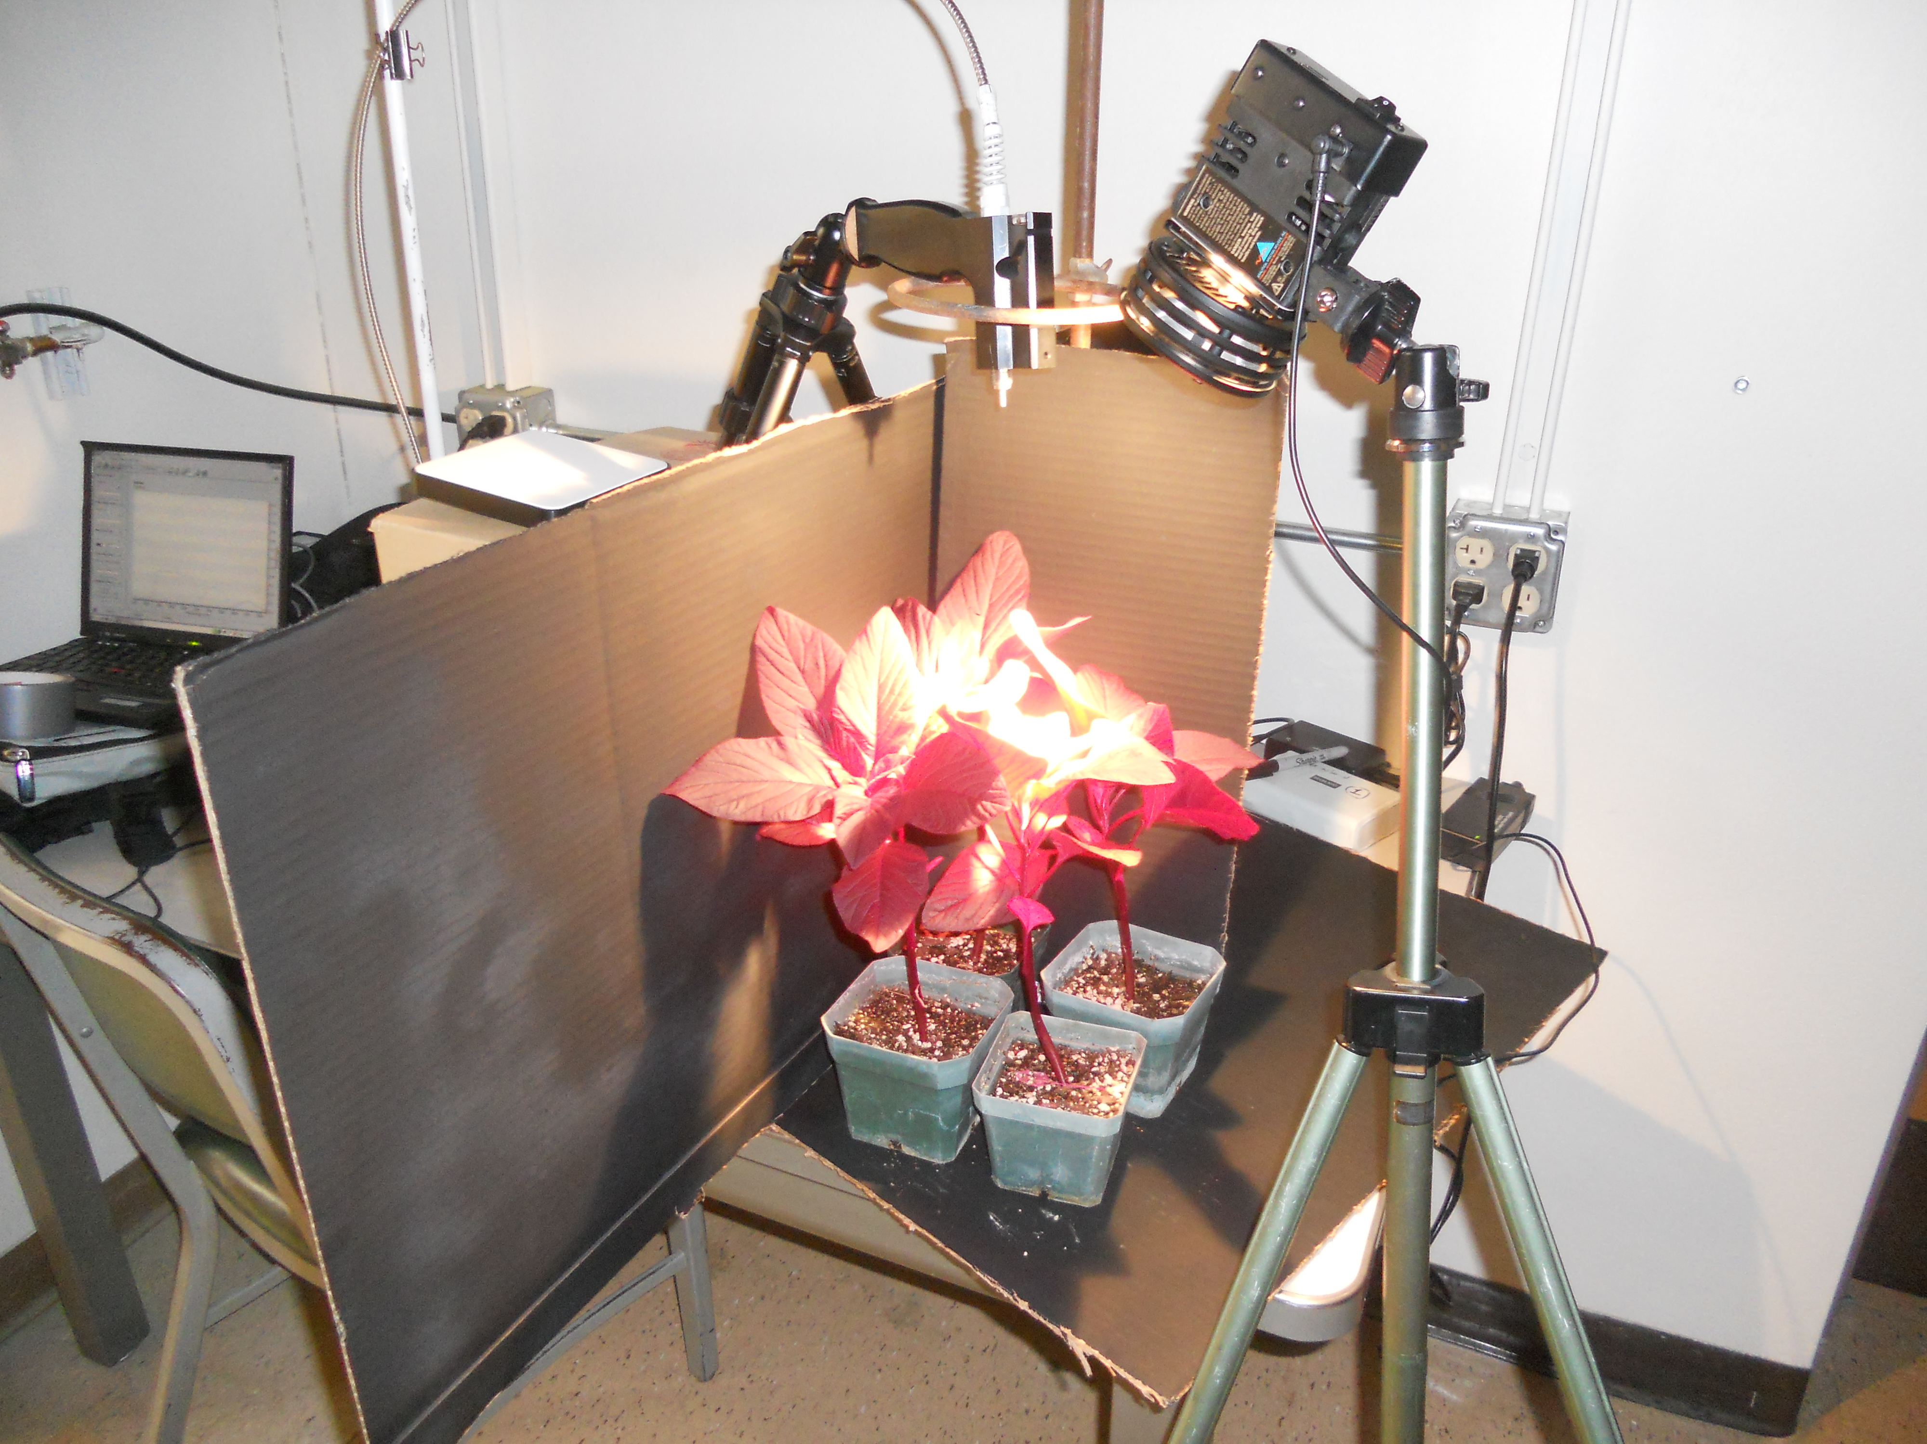
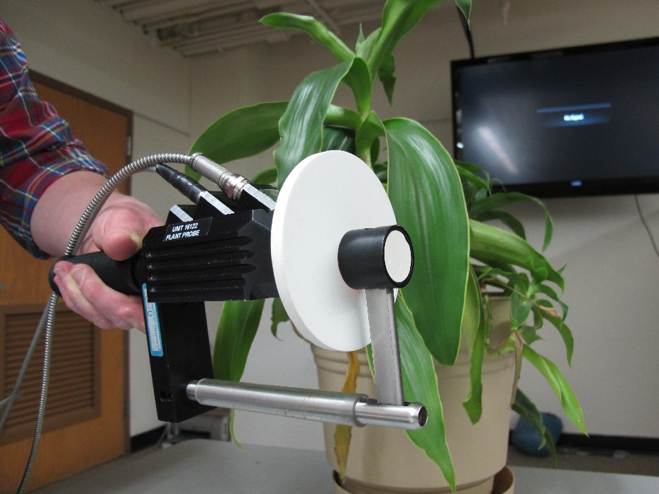
FIGURES
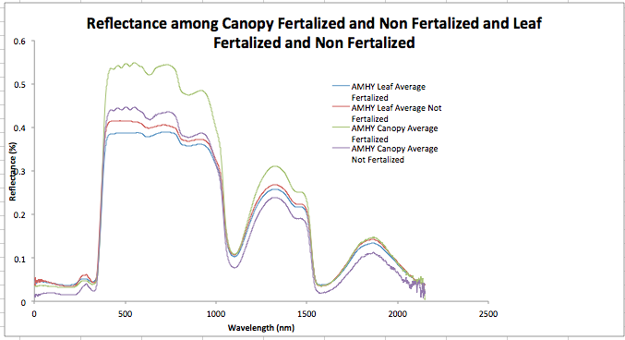
Table 1: Shows equations used to calculate indices used in this study
Figure 2: Set-up for canopy data collection
Figure 1: Spectralon white reference puck in plant probe and leaf clip assembly

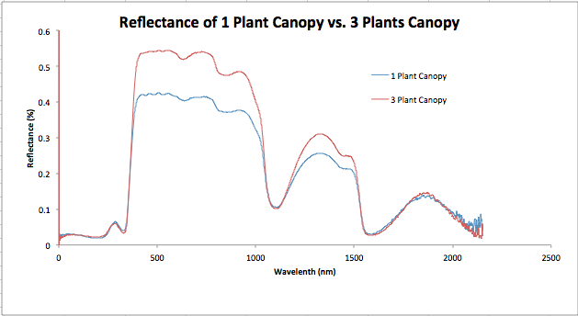
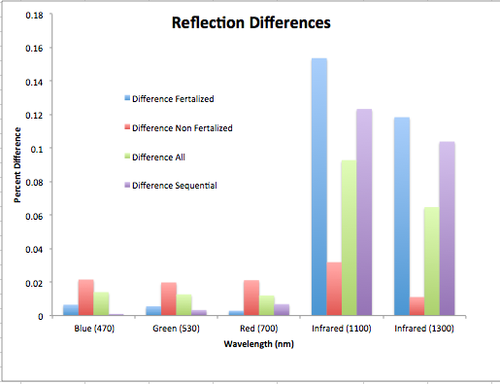
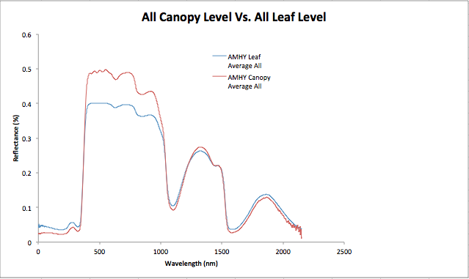
Figure 3:Top shows Reflectance measurements of canopy and leaf level, fertilized and non-fertilized. Middle shows reflectance data for all canopy and all leaf level measurements. Bottom left shows reflectance measurements for canopy with 1 plant and canopy with 3 plants. Bottom right shows percent difference between canopy and leaf level reflectance at wavelengths 470, 530, 700, 1100, and 1300nm.

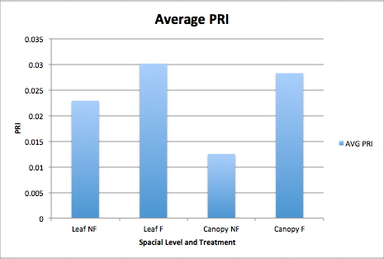
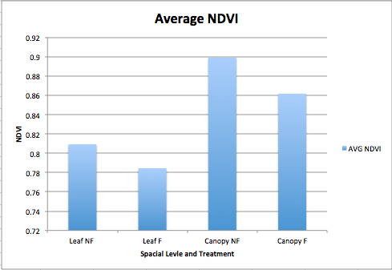
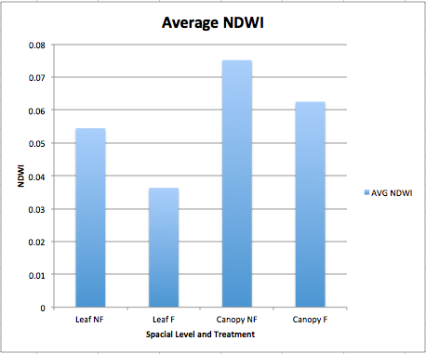

Figure 4: Average values of PRI (Top left), NDVI (top right), and NDWI (bottom left) of fertilized (F) and non-fertilized (NF) leaf level (leaf) and canopy level (canopy) measurements

Treatment factors | PRI |  | NDVI |  | NDWI
 | F | P | F | P | F | P
Fertilization | 8.7 | 0.015 | 8.4 | 0.016 | 21.4 | 0.001
Community | 2.5 | 0.148 | 60.7 | <.0001 | 49.6 | <0.001
Fertilization x community | 1.2 | 0.300 | 0.4 | 0.567 | 0.7 | 0.428

Table 2: Comparison of photochemical reflectance index (PRI), normalized difference vegetation index (NDVI), and normalized difference water index (NDWI) determined from spectra collected from individual leaves or simulated canopies supplemented either 0 g /wk or 0.132 g/wk-2 NH₄NO₃ as a nitrogen amendment

